**Traffic Clearance for Ambulance/ (or other priority Vehicle) through**

**Artificial Intelligence**

**Reference:**

<https://www.irjet.net/archives/V4/i3/IRJET-V4I3320.pdf>

For Traffic clearance using wireless:

<https://www.researchgate.net/publication/220586947_Intelligent_Traffic_Light_Flow_Control_System_Using_Wireless_Sensors_Networks>

FPGA Based Real Time Traffic Detection(Field Programmable Gate Arrays (FPGAs) are semiconductor devices that are based around a matrix of configurable logic blocks (CLBs) connected via programmable interconnects. )

<https://ijcrt.org/papers/IJCRT2006625.pdf>

This is based on vehicular density

<https://www.irjet.net/archives/V6/i4/IRJET-V6I414.pdf>

**Conclusion:**

There are a digital device like a tablet set in an ambulance.



In this Device There are Features to show the shortest path, and the send signal nearest crossroad traffic signal.

On a crossroad traffic signal there is a camera.

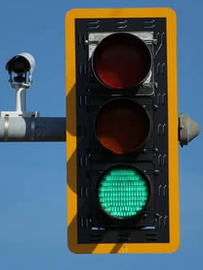

This Camera analyzes real time and In this procedure we can run an ML algorithm to detect and count no of vehicles on the crossroad. On count there vehicles how many vehicles are there we can find it.

Now the Sensor send a signal on a device that are already fitted on a ambulance.

Now receive signals on our device that are fitted on a ambulance.

Ambulances get signals and move on to reach their destination.

Once ambulances reach near 1km or 600meter that time another signal automatically passes on crossroad traffic lights and sensors.

At that time a signal is automatically handled by our automation machine learning system and signals are set green and other lan signals are red.

In this traffic signal handled system we use a traffic automation algorithm for handle traffic light.

Ambulance passes and we can save other lifes.